OP-AMP PID Controller Simulation – ARC Task
Nikhil Ramamurthy
2025A4PS0450H

Sin Wave
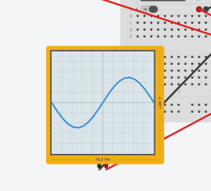
Proportional Circuit Integral Circuit
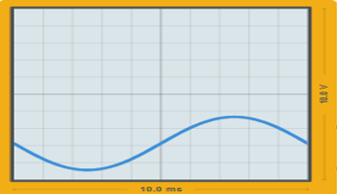

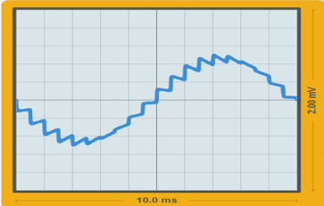
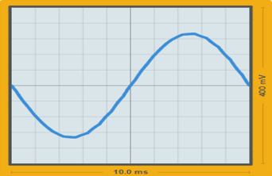
Differentiator Circuit Total PID Response

Tinker CAD Link : https://www.tinkercad.com/things/jNWNY5HWpNV-op-amp-pid-controller-simulation-final

Square Wave
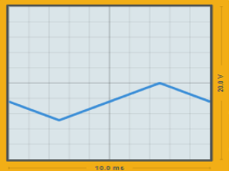
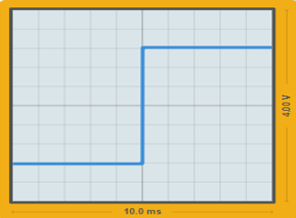
Proportional Circuit Integral Circuit

Differentiator Circuit Total PID Response
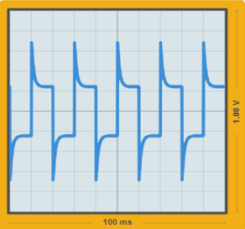
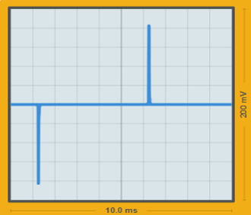

Sawtooth/Triangle Wave
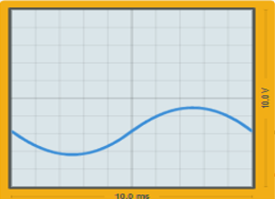
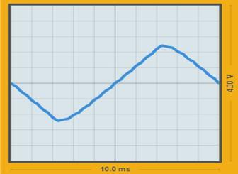
Proportional Circuit Integral Circuit

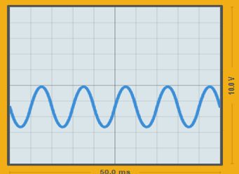
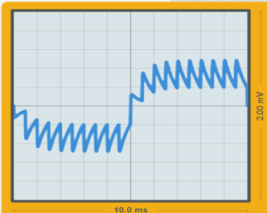
Differentiator Circuit Total PID Response

